Task 7
Practice task
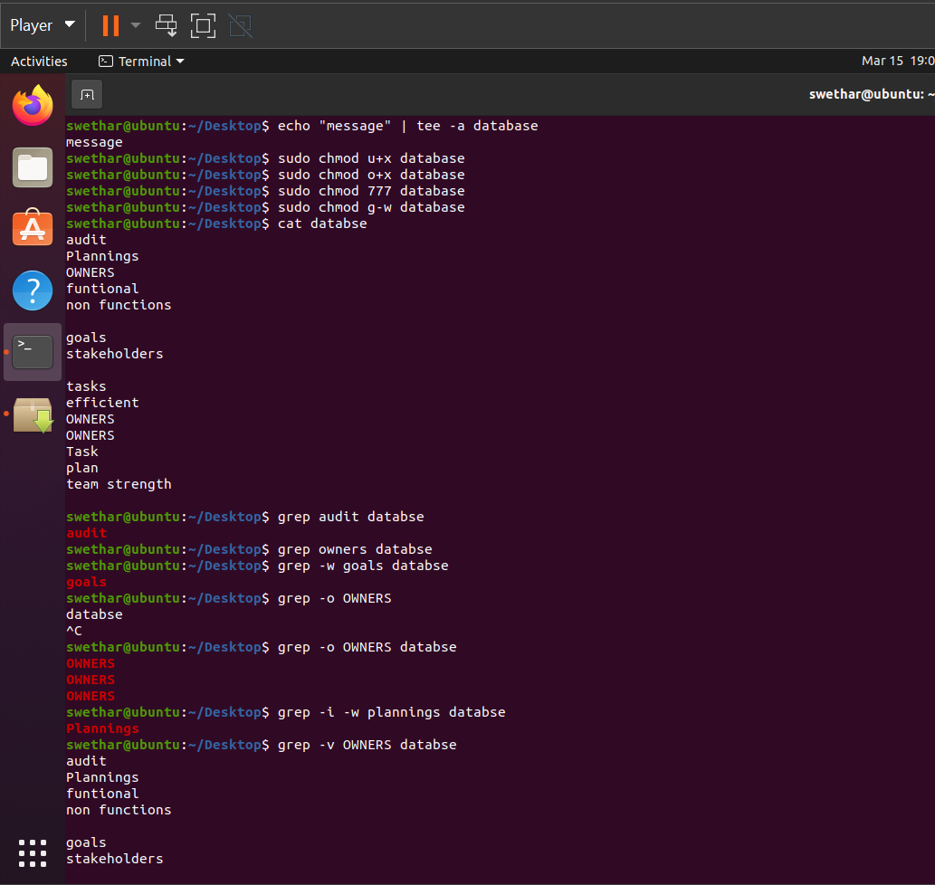

Additional task
1.Explain the working of this command ---> echo "message" | tee -a file.txt
tee writes the input to a file and also to the terminal.
-a → append the message to file.txt instead of overwriting it.
2.Explore on free and free -h command
free → displays memory usage: total, used, free, shared, buffer/cache, and available memory (in KB by default).
free -h → shows the same information in human-readable format (KB, MB, GB), easier to understand.
3.How do you count the number of lines that contain a specific word using wc and grep?
grep "word" filename | wc -l
4.What does this command will do----> sudo chgrp <groupname> <file-name>
It changes the group ownership of a file.
5.How to identify soft/symbolic link
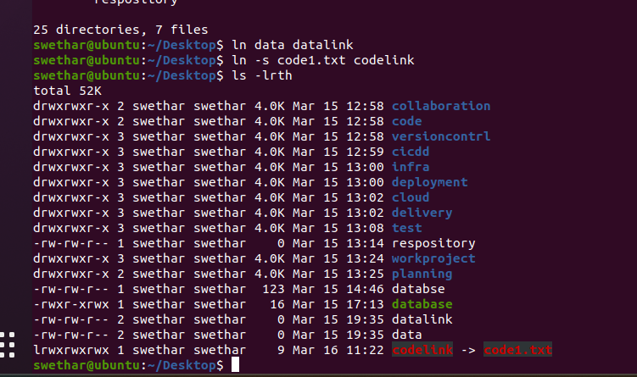
l at the beginning → indicates a symbolic (soft) link
6. Can we create a link for files and dir's
Yes, we can create links for both files and directories.
ln -s <target> <link-name>
below screenshot has link created for directory
